# Profiling using consul

We can utilize consul config properties to do profiling of our spring-boot projects. This helps us maintain different sets of properties according to the deployment environment.

1. Add consul dependency in your pom.xml

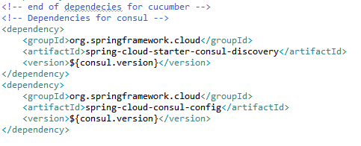

1. Add below properties in your bootstrap.properties or bootstrap.yaml.

Notice spring.cloud.consul.config.* properties; making fail-fast true ensures that the application checks connection before starting up the server so that if consul server is not available then the application doesn’t startup and it can be remedied beforehand. Format property defines the type of property file stored on consul.

Below is screen capture of properties file.

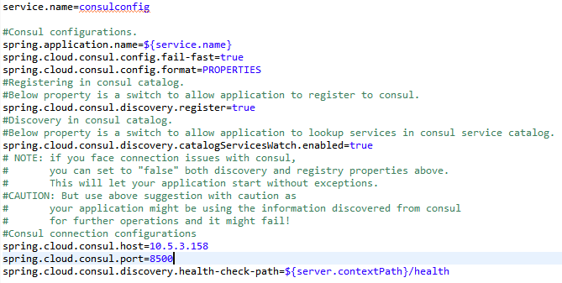

1. Add property files with data key on your consul server with REST PUT service provided by consul API. For example:-

http://<host>:8500/v1/kv/config/consulconfig,dev/data

with binary type of data in PUT request body that is your property file for dev environment. “consulconfig” is the same name of your application as registered on consul as mentioned in the properties file property – spring.application.name.

More URLs can be like:

http://<host>:8500/v1/kv/config/consulconfig,production/data

http://<host>:8500/v1/kv/config/consulconfig,local/data

You can also set a default property incase no spring active profile is provided while running project with below URL.

http://<host>:8500/v1/kv/config/consulconfig/data

1. Now you can start your spring-boot application. The application first makes connection with consul server and then checks the profile provided as parameter for running the jar: -*Dspring.profiles.active*=local and matches the data key with the profile to read the properties. After the properties are read, then it makes connection to your DB server or caching server or any other third party server configured. Also, reads custom properties to provide values to spring components.

If no active profile is provided, it looks for default properties data key and loads those properties